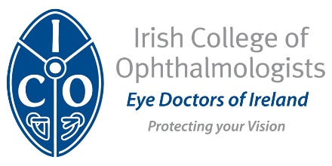

Application for Exit Assessment
Specialty Training in Medical Ophthalmology – old pathway

NAME

Email Address | IMC Number
Date of CCBST

Post BST Training Posts (to include date of post, unit, trainer & sub specialty focus)

- Post:
Date:
Trainer:
Unit:
Sub specialty:

- Post:
Date:
Trainer:
Unit:
Sub specialty:

Have you passed the European Board of Ophthalmology Diploma? When?

Closing Date for Applications for Assessment; Friday 25th October
Please return completed form to rob.tracey@eyedoctors.ie

